Activity time
Looking for Jesus binoculars
In the Bible reading it says And their eyes were opened, and they recognized him. –Luke 24:31
Using a kitchen roll tube (or alternative) make some binoculars as a reminder that we need to look for and see Jesus. Stick 2 kitchen roll tubes together or cut one in half and stick them together with Sellotape. Decorate them.
The binoculars can help children to understand that we need to open our eyes to see Jesus.
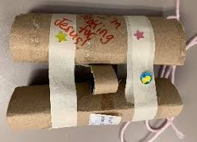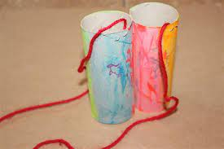

Walking picture
Colour the attached picture and cut out the people and either stick on the background or stick them on a lolly stick/ piece of card and cut a slit in the picture to make the followers and Jesus walk along the road.
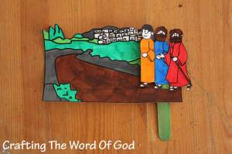

Footprints
Jesus walked alongside His followers. As a reminder that we too are walking with Jesus you could make some painted footprints or draw around your feet and cut them out. Perhaps make a trail to follow out of footprints.
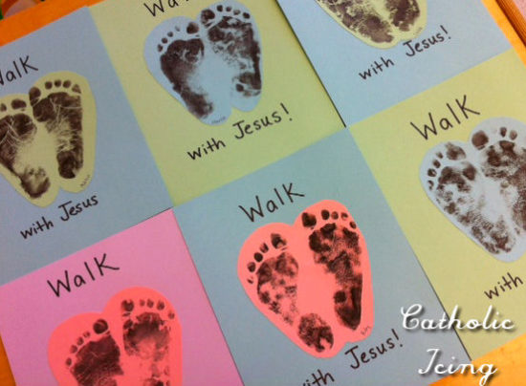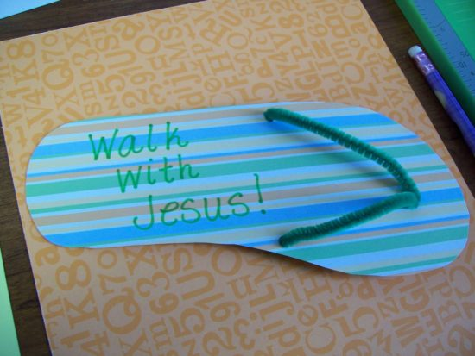

Wordsearch, maze and crossword
These are attached to the email.

