Jesus’
Baby
Book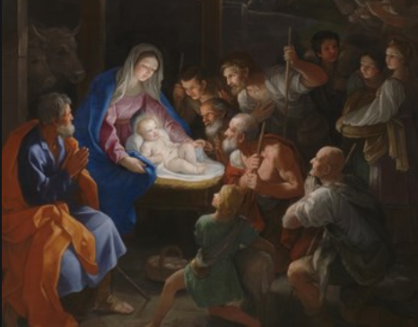

My first visitors

My first gifts

Why did people come to see me?

My trip to the temple

