Ruth: Faithfulness Paper Braid and Prayer Activity (from Flame Creative website)
Where you go I will go, and where you stay I will stay. Your people will be my people and your God my God. Ruth 1:16
Ruth is a great book to use to teach children about loyalty and faithfulness. Ruth stays faithful to her mother-in-law, Naomi, and leaves her own community to join Naomi's. Not only this, but she takes on a faithfulness to Naomi's God and becomes an ancestor of David- an amazingly important woman!
There are so many themes to pick up here...
- welcoming new people into a family or community
- who takes care of us and who we take care of (and why we do this)
- what it means to become one of God's people
- how God works through unexpected people
Here is a craft (inspired by this post on Scrapbooks etc) to help pick up and explore the theme of the unity that comes from faithfulness to each other and to God:
You will need: 4 strips of coloured paper (2 of one colour and 2 of another colour). Mine were about 1cm thick and 15 cm long; glue.
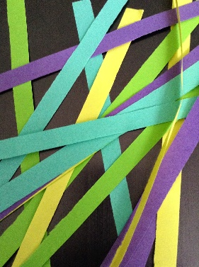
Take your first colour and glue at right angles like so.
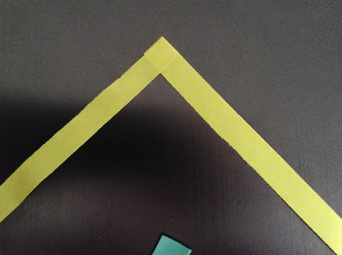
Then glue the 2 strips of the second colour over the top as below.
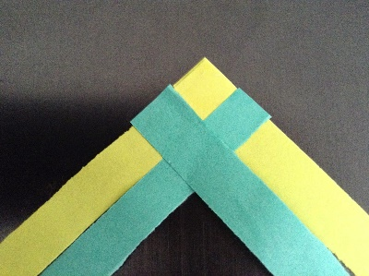
Fold the colour 1 strips over the colour 2 strips as shown and continue...
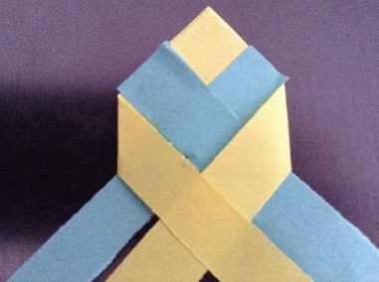
...all the way to the end. Secure ends with glue.
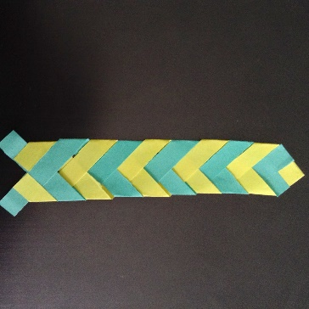
Talk about:
- Like the braided paper, Ruth joined her life together with Naomi and with God. Who is your life joined to?
- Why do you think Ruth decided to stay with Naomi? What would you have done?
- The unity of the braid makes the paper strips much stronger than they were separately. How might this be similar when we join with others in community and with God?
Pray:
- Make another braid. Choose one colour to represent God and another colour to represent yourself or someone you know. As you braid the strips together, pray that you or the person you have chosen will grow closer to God.

Basket of barley

