Elijah is fed by ravens craft
This week our 3-5s will be learning the story of Elijah being fed by ravens and how this reminds us that God will look after us and give us the things we need.
This is a fairly easy craft that the children can then use to reenact the story as the button 'bread' can be taken off and put back on again and the pipe cleaner means that the bird can 'fly'!
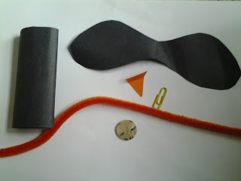
You will need: A tube made from rolled up black paper, some black paper wings, a card beak (I am reliably informed that ravens have black beaks but I was ignorant of this when I started!), a paperclip, a brown/ neutral button and a pipe cleaner.
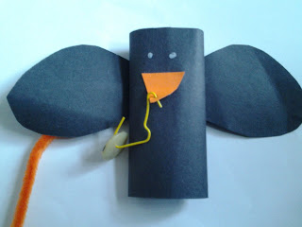
Stick the wings and beak onto the tube and give the bird some eyes. open out and bend a paper clip, make a hole in the beak and stick it through. Hook a button onto the paper clip. Push a pipe cleaner through the back of the tube and secure.
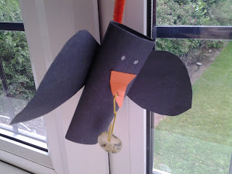
Now the raven can carry bread and children can use the pipe cleaner to make it fly!

