The Last Supper
Maundy Thursday or the commemoration of the Last Supper is the Thursday before Easter.
Take some time to sit and talk with your children and ask a few questions whilst sharing some bread like Jesus and the disciples.
Some things to think about:
Jesus showed how much he loved his friends by washing their feet and by sharing a special meal with them.
Who are your friends?
How would you help them? What would you share with them?
Share some of the bread and think about what you would do. Ask God to be with your friends.

Last Supper Play Dough Mats
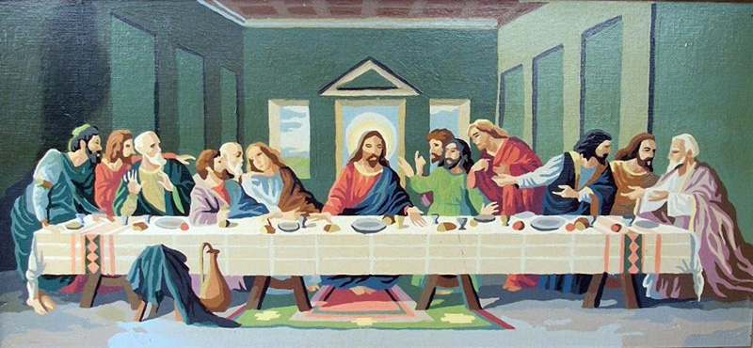
Here's a play dough mat- this time to help children to reflect on the last supper. It might also come in handy when helping children to understand what communion is about. It is attached in the page below!

