Good Friday!
The day the Jesus was crucified!
Craft ideas:
It's quick, easy and makes a really colourful resurrection cross to celebrate Jesus rising to new life!
- Cut out a cross shape (A4 card)
- Stick masking tape (or any tape) over the cross in whatever pattern you like!
- Dip the ends of chalk in water and paint with it in the spaces created by the masking tape. (It doesn't matter if you go over the edges of the tape!) Also, you don’t have to use chalk this is just a suggestion! You can use pens, pencils, paints, whatever you have!
- Let it dry, and carefully remove the tape from the cross!
Example below:
I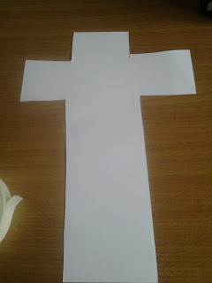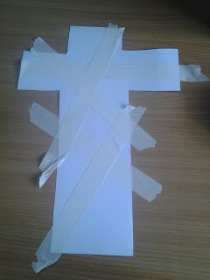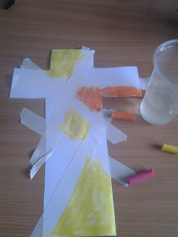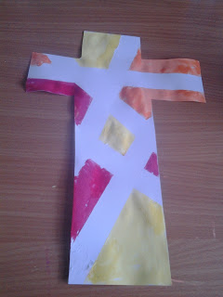
If you choose to make these, please share them with you! Put them in your windows or send them to us!

