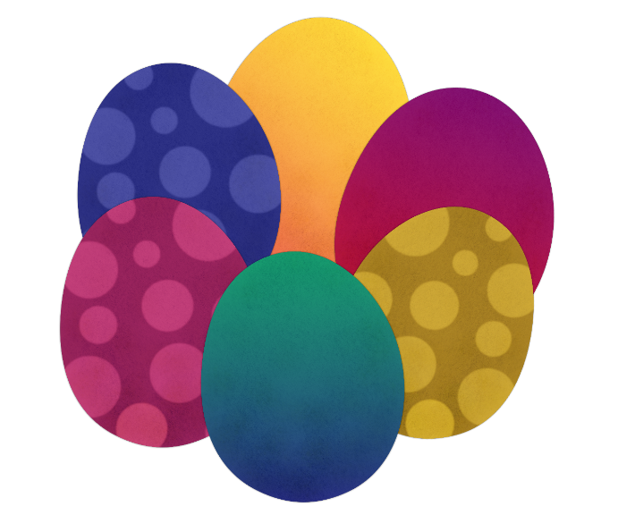
Easter Sunday
Hallelujah! Christ Has Risen!
Today we celebrate the resurrection of Jesus!
Along with all your Easter Egg eating, and all the Easter egg hunts! Please have a go at these activities!
New life butterflies
Butterflies are great symbols of new life when you are talking about the resurrection. These are really easy and really effective to make- but are probably best made by older children as the folding can be a bit fiddly!
- First get a brightly coloured page from a magazine,
- Then cut it into 2 squares- I used one 12 x12 cm and one 8cm x 8cm
- Starting with a corner, concertina the paper diagonally
- Tie the two concertinaed squares together with thread.
- Hang the butterflies up!
(Pictures on the following page)
Before you do this, though:
3 days after he died, Jesus rose to new life!
Christians believe that Jesus brings us hope and new life.
What are your hopes and dreams? Where in your life would you like a new start?
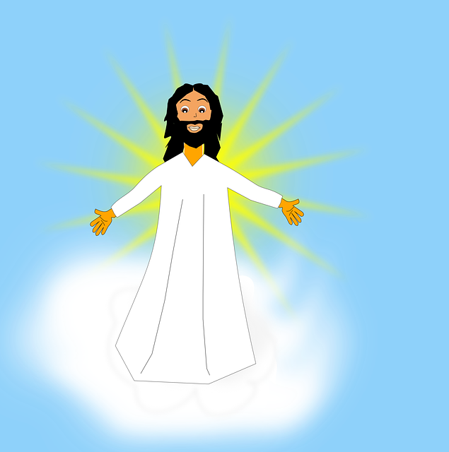
Why don’t you write or draw your ideas on your
Paper, before you make your butterflies before you
Hand them up!

Hallelujah! He is risen!

